Homework 6: Reinforcement Learning

Name _______________________________

Question 1: Model-Based RL: Grid
0.0/4.0 points
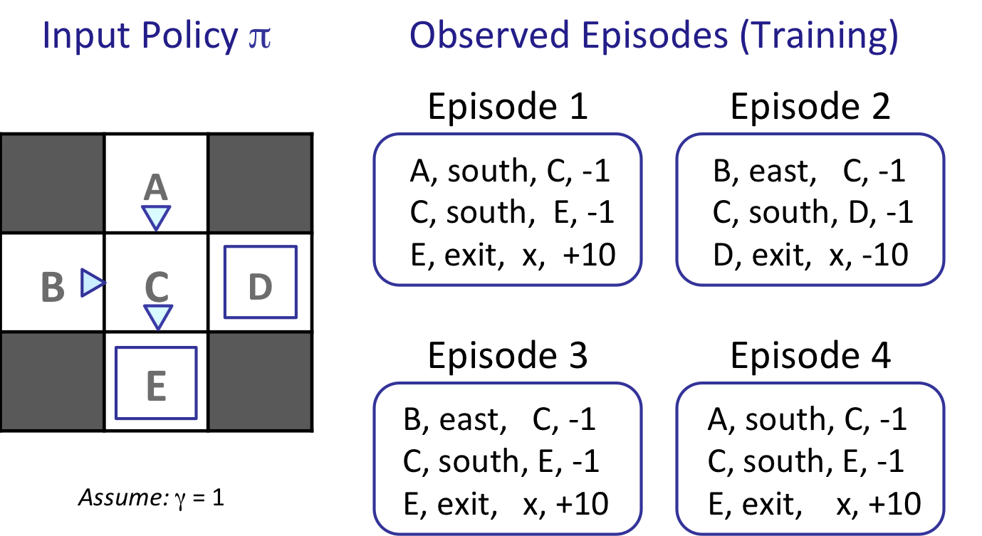
What model would be learned from the above observed episodes?
T(A, south, C) =
T(B, east, C) =
T(C, south, E) =
T(C, south, D) =

Question 2: Model-Based RL: Cycle
0.0/26.0 points
We recommend you work out the solutions to the following questions on a sheet of scratch paper, and then enter your results into the answer boxes.

This section will reset, so send me a screenshot of your correct answer.
Consider an MDP with 3 states, A, B and C; and 2 actions Clockwise and Counterclockwise. We do not know the transition function or the reward function for the MDP, but instead, we are given samples of what an agent experiences when it interacts with the environment (although, we do know that we do not remain in the same state after taking an action). In this problem, we will first estimate the model (the transition function and the reward function), and then use the estimated model to find the optimal actions.
To find the optimal actions, model-based RL proceeds by computing the optimal V or Q value function with respect to the estimated T and R. This could be done with any of value iteration, policy iteration, or Q-value iteration. Last week you already solved some exercises that involved value iteration and policy iteration, so we will go with Q value iteration in this exercise.
Consider the following samples that the agent encountered. (Note that nan stands for not-a-number and indicates that this entry cannot be estimated from the samples.)

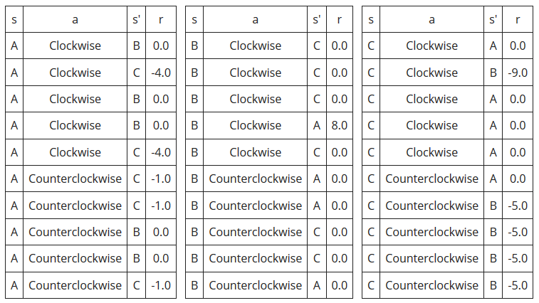

Part 1
We start by estimating the transition function, T(s,a,s') and reward function R(s,a,s') for this MDP. Fill in the missing values in the following table for T(s,a,s') and R(s,a,s').
Discount Factor, γ = 0.5
s a s' T(s,a,s') R(s,a,s')  A Clockwise B M N  A Clockwise C O P  A Counterclockwise B 0.400 0.000  A Counterclockwise C 0.600 -1.000  B Clockwise A 0.200 8.000  B Clockwise C 0.800 0.000  B Counterclockwise A 0.600 0.000  B Counterclockwise C 0.400 0.000  C Clockwise A 0.800 0.000  C Clockwise B 0.200 -9.000  C Counterclockwise A 0.200 0.000  C Counterclockwise B 0.800 -5.000 | M  N  O  P

Part 2
Now we will run Q-iteration using the estimated T and R functions. The values of Q_{k}(s,a), are given in the table below.
 | A | B | C
Clockwise | -1.48 | 0.82 | -1.88
Counterclockwise | -0.82 | -0.54 | -3.42

Fill in the values for Q_{k+1}(s,a).
 | A | B | C
Clockwise
Counterclockwise

Part 3
Suppose Q-iteration converges to the following Q* function, Q*(s,a).
 | A | B | C
Clockwise | -1.856 | 0.609 | -2.194
Counterclockwise | -1.136 | -0.78 | -3.87

What is the optimal action, either Clockwise or Counterclockwise, for each of the states?

A | B | C

Question 3: Direct Evaluation
0.0/10.0 points
What are the estimates for the following quantities as obtained by direct evaluation:
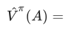

Question 4: Temporal Difference Learning
0.0/10.0 points
Consider the gridworld shown below. The left panel shows the name of each state A through E. The middle panel shows the current estimate of the value function V^{π} for each state. A transition is observed, that takes the agent from state B through taking action east into state C, and the agent receives a reward of -2. Assuming γ =1, α = 1/2, what are the value estimates after the TD learning update? (note: the value will change for one of the states only)
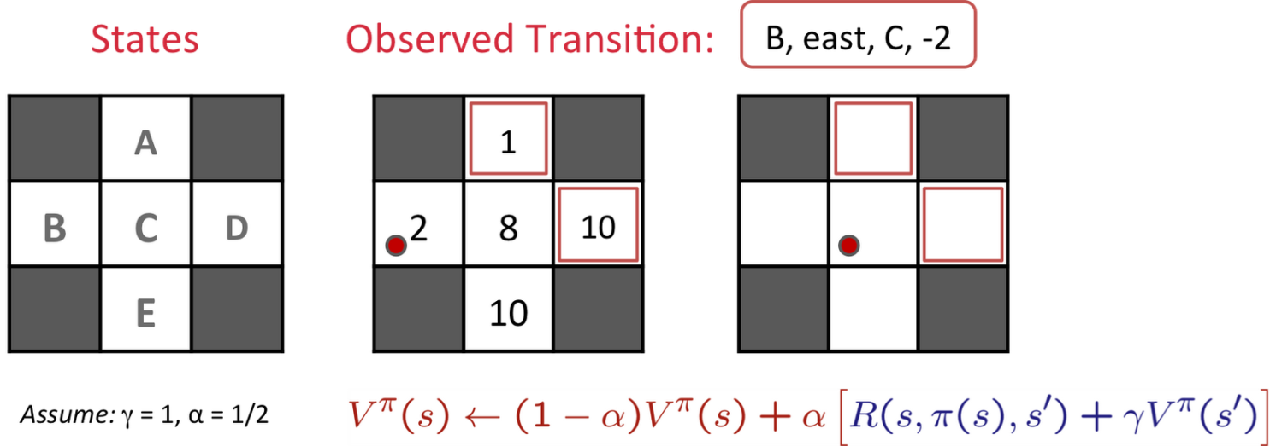
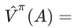

Question 5: Model-Free RL: Cycle
0.0/12.0 points
We recommend you work out the solutions to the following questions on a sheet of scratch paper, and then enter your results into the answer boxes.
This section will reset, so send me a screenshot of your correct answer.
Consider an MDP with 3 states, A, B and C; and 2 actions Clockwise and Counterclockwise. We do not know the transition function or the reward function for the MDP, but instead, we are given with samples of what an agent actually experiences when it interacts with the environment (although, we do know that we do not remain in the same state after taking an action). In this problem, instead of first estimating the transition and reward functions, we will directly estimate the Q function using Q-learning.
Assume, the discount factor, γ is 0.5 and the step size for Q-learning, α is 0.5.
Our current Q function, Q(s,a), is as follows.

 | A | B | C
Clockwise | 0.372 | 0.836 | 2.097
Counterclockwise | 6.999 | -1.686 | 3.443

The agent encounters the following samples.

s | a | s' | r
A | Clockwise | C | -7.0
C | Counterclockwise | B | 4.0

Process the samples given above. Below fill in the Q-values after both samples have been accounted for.

 | A | B | C
Clockwise
Counterclockwise

Question 6: Q-Learning Properties
0.0/4.0 points

In general, for Q-Learning to converge to the optimal Q-values...

It is necessary that every state-action pair is visited infinitely often.
It is necessary that the learning rate α (weight given to new samples) is decreased to 0 over time.
It is necessary that the discount γ is less than 0.5.
It is necessary that actions get chosen according to argmax_{a}Q(s,a).

Question 7: Exploration and Exploitation
0.0/10.0 points

For each of the following action-selection methods, indicate which option describes it best.

A: With probability p, select argmax_{a}Q(s,a). With probability (1-p), select a random action. p – 0.99
Mostly exploration
Mostly exploitation
Mix of both

B: Select action a with probability
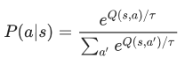
where τ is a temperature parameter that is decreased over time.
Mostly exploration
Mostly exploitation
Mix of both

C: Always select a random action.
Mostly exploration
Mostly exploitation
Mix of both

D: Keep track of a count, K_{s,a}, for each state-action tuple, (s,a), of the number of times that tuple has been seen and select argmax_{a}[Q(s,a) – K_{s,a}].
Mostly exploration
Mostly exploitation
Mix of both

Which method(s) would be advisable to use when doing Q-Learning?
A
B
C
D

Question 8: Feature-Based Representation: Actions
0.0/6.0 points
Consider the two Pacman board states presented in two rows below. In each row, the agent considers possible actions to take; these are represented by the images. The agent is using feature-based representation to estimate the Q(s,a) value of taking an action in a state, and the features the agent uses are:
- f₀ = 1/(Manhattan distance to closest food + 1)
- f₁ = 1/(Manhattan distance to closest ghost + 1)
For example, the feature representation f(s = A, a = STOP) = [1/4, ¼].

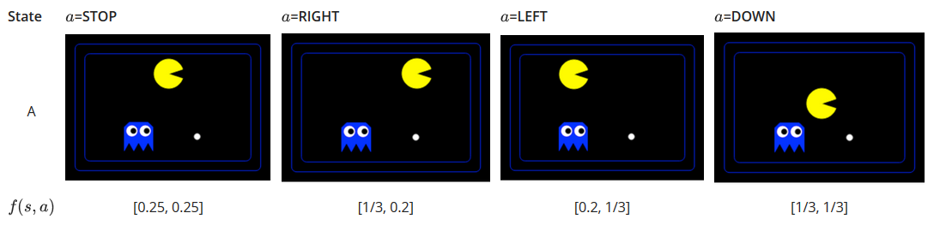

The agent picks the action according to argmax_{a}Q(s,a) = w^{T}f(s,a)=w₀f₀(s,a) + w₁f₁(s,a), where the features f_{i}(s,a)are as defined above, and w is a weight vector. Using the weight vector w = [0.2, 0.5], which action, of the ones shown above, would the agent take from state A?
STOP
RIGHT
LEFT
DOWN

Using the weight vector w = [0.2, -1], which action, of the ones shown above, would the agent take from state A?
STOP
RIGHT
LEFT
DOWN

Question 9: Feature-Based Representation: Update
0.0/18.0 points
Consider the following feature based representation of the Q-function:
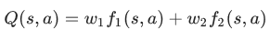
with:
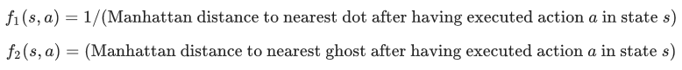

Part 1
Assume w₁ = 1, w₂ = 10. For the state s shown below, find the following quantities. Assume that the red and blue ghosts are both sitting on top of a dot.
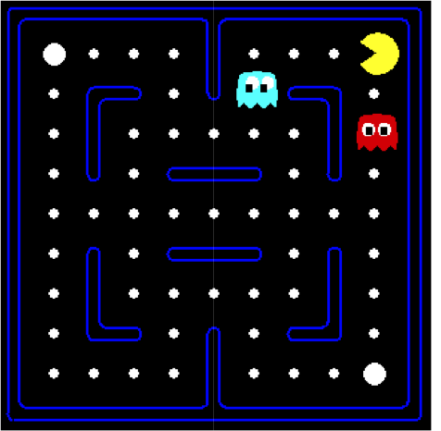

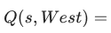

Based on this approximate Q-function, which action would be chosen:
West
South

Part 2
Assume Pac-Man moves West. This results in the state s’ shown below.

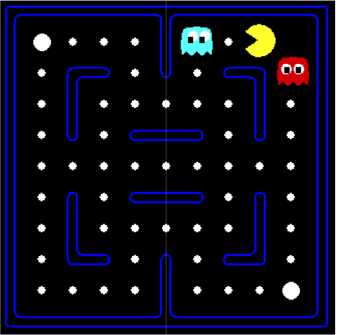
The reward for this transition is r = +10 -1 = 9 (+10: for food pellet eating, -1 for time passed). Fill in the following quantities. Assume that the red and blue ghosts are both sitting on top of a dot.
What is the sample value (assuming γ = 1)?

Part 3
Now let's compute the update to the weights. Let α = 0.5.

